5G-Enabled AI Smart Classroom Attendance System
Indian Institute of Technology, Guwahati
Department of Electronics and Electrical Engineering

Team Members:
K Vasanthakumaaran
Adweit
Abhay

Abstract
This project proposes a smart classroom attendance system that leverages AI and 5G connectivity to automate and enhance the process of attendance tracking. Traditional attendance methods are time-consuming, prone to errors, and susceptible to proxy attendance. Our solution utilizes computer vision techniques to recognize students in real-time through classroom cameras and automatically log their attendance.
By integrating 5G networks, the system ensures ultra-low latency communication and high bandwidth, enabling seamless processing of live video streams across multiple classrooms simultaneously. This solution aims to improve efficiency, accuracy, and scalability in educational institutions while demonstrating the transformative potential of AI and 5G technologies.

Problem and Motivation
Manual attendance systems consume valuable classroom time and are prone to inaccuracies. Even existing biometric or RFID-based systems fail to prevent proxy attendance effectively and often require physical interaction. Furthermore, these systems lack scalability and real-time monitoring capabilities, especially in large institutions with multiple classrooms.
With increasing class sizes and the need for digital transformation in education, there is a strong demand for an automated, reliable, and scalable attendance system. The integration of AI and next-generation communication technologies like 5G provides an opportunity to address these limitations efficiently.

Proposed Solution
We propose an AI-based attendance system that uses classroom cameras to capture live video feeds and identify students using facial recognition. The system automatically marks attendance when a student is detected and verified against a pre-registered database.
The architecture consists of:
- A camera module for capturing real-time video
- An AI module for face detection and recognition
- An edge/cloud system for processing and storage
- A dashboard for viewing attendance records and analytics

The system operates in real-time and minimizes manual intervention, ensuring a seamless and efficient attendance process.
Detailed Architecture
There are open-source models available which can perform face detection. In our project, we will be using RetinaFace to implement the AI face recognition component. The open-source models have a high accuracy of close to 99.9% of recognising the face The steps in which the attendance will be marked are as follows:
- The AI model will run on a remote system connected to the 5G camera over the 5G network.
- This computer will get the video feed from the camera, but we really do not need a video feed. So, we propose to capture snapshots of the video and identify the faces in each of these images.
- After the faces are identified we will run a Face recognition algorithm which will detect the faces and annotate the image with the different people in the snapshot.
- Once the people are identified, an excel sheet is created which has the list of the students who have attended the class.
- Now we will repeat the step 3 with a different snapshot of the same classroom and we will update the excel sheet if anybody’s attendance has been missed in the first snapshot.
- This process will take place till 5 minutes after the start of the class and the system will automatically switch off to save the network bandwidth and consumption.

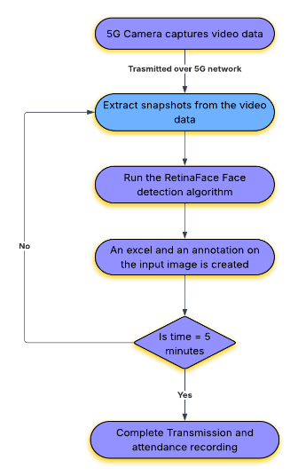

Use Cases & Impact
This system can be deployed in:
- Educational institutions such as schools and universities
- Large lecture halls with high student density
- Corporate training environments
- Examination settings to prevent impersonation

The impact includes:
- Significant reduction in time spent on attendance
- Improved accuracy and elimination of proxy attendance
- Scalable solution for large institutions
- Foundation for advanced analytics such as student engagement monitoring
Challenges
There are few challenges with the current proposed solution. We will now look at some of the challenges and how they can be solved.
- Attendance cheating: It is possible that the students might just show the picture of a friend on the phone and still the camera might identify the person. This leads to fake attendance.
One way is to check manually with the output annotated image by a human presence. But this leads to overhead on the person who is checking the attendance.
Another way to solve this is to include another ML model which might detect if a picture is being shown from a phone or not, and we could also inplement motion detection algorithms to verify that the person is physically present.
- Huge Classroom: If there is a huge classroom, then we cannot use the image to identify because the resolution of the faces in the picture decreases and this can reduce the accuracy of the face recognition model.
We can solve this by taking multiple snapshots of the classroom each at a different angle or we could use multiple camera which can cover the entire classroom and each camera will connect to the 5G network individually and once all the data has been processed, we will merge the two excel sheets created to get the attendance.

